[Date]
Akbar Qamar
[Company name]
[Company address]
[Document title]
[Document subtitle]
Contents
SECTION 1 — DEMONSTRATION OVERVIEW (WHAT YOU BUILT AND WHAT YOU WILL SHOW) 3
1.1 Short purpose statement (3–6 lines) 3
1.2 Evidence map (fill in) 3
SECTION 2 — REQUIRED DIAGRAMS (INSERT THESE TWO IMAGES IN YOUR TEMPLATE DOCUMENT) 3
SECTION 3 — SYSTEM DOCUMENTATION (IO ALLOCATION TABLE + SIGNAL MAPPING) 4
SECTION 4 — WIRING AND CONFIGURATION (REQUIRED) 5
SECTION 5 — OPERATION CYCLE DEMONSTRATION (NORMAL RUN) (REQUIRED) 6
SECTION 6 — ERROR SIMULATION (REQUIRED) 6
SECTION 7 — TROUBLESHOOTING (REQUIRED) 7
SECTION 8 — COMMUNICATION LINKS AND STANDARDS (LO2.P3) 8
SECTION 9 — NETWORKED BUS PLC SYSTEMS (LO2.P4) 9
SECTION 10 — HMI AND SCADA INTEGRATION (LO2.M2 and LO2.M3) 10
SECTION 11 — CONVERGENCE RATIONALE (LO2.D2) 11
SECTION 12 — LAB RECORD (REQUIRED) 11

No table of figures entries found.

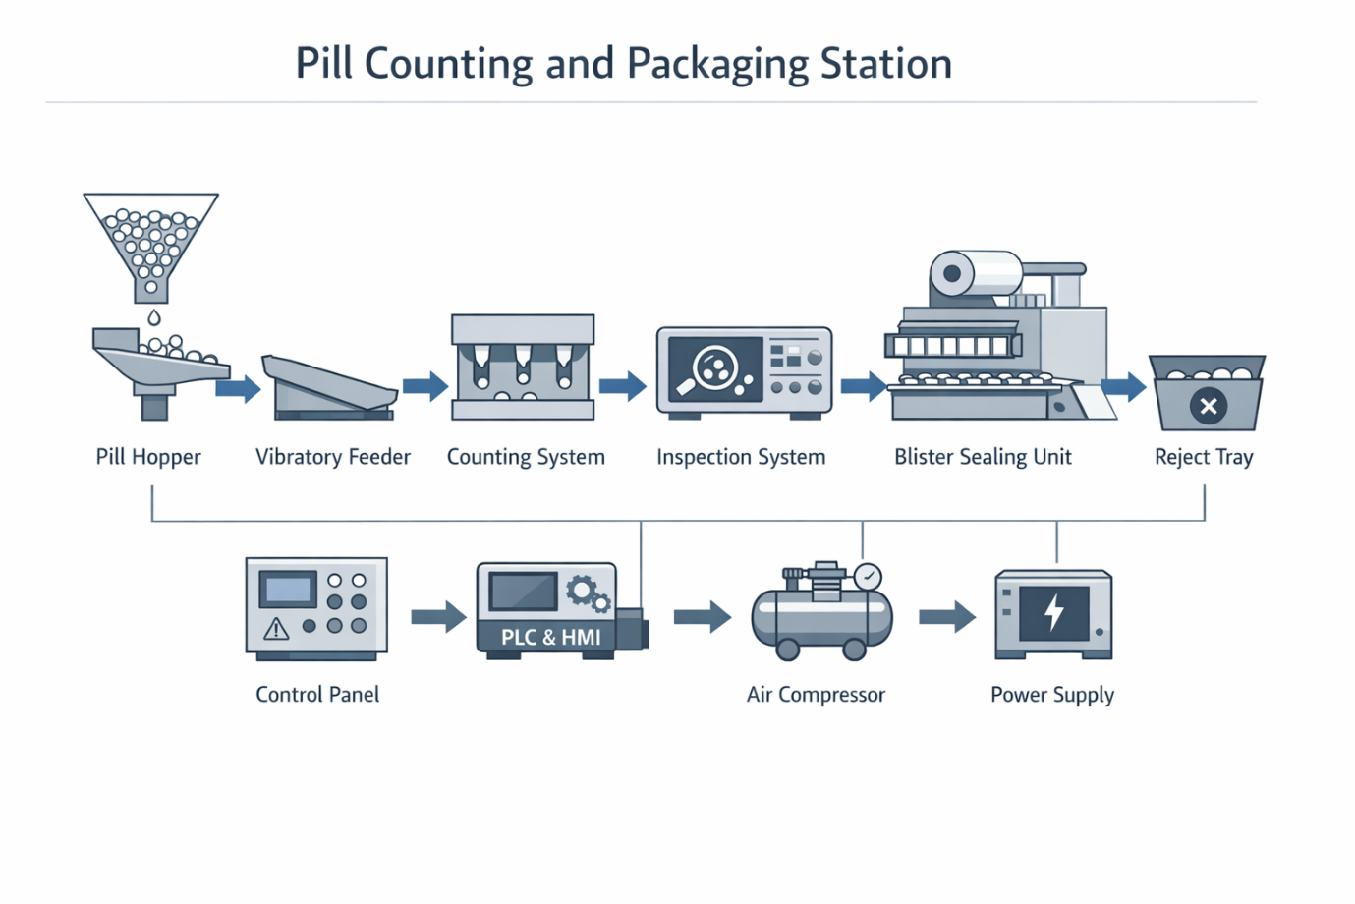
This diagram shows the whole pill counting and packaging station at a system level. The Start, Reset, Emergency Stop, and pill sensor are the inputs that go into the PLC digital inputs. The PLC then decides what to do based on its program (scan cycle), and it turns outputs on/off to control the packaging actuator and the buzzer.
Figure 0.1 Full Diagram
It also shows the supporting parts that make the system work in real life, such as the 24 V DC power supply and protection (fuse/MCB). If the diagram includes communications, the PLC network connection (e.g., Ethernet/fieldbus) is there so the station can connect to HMI/SCADA for monitoring, alarms, and logging. The key idea is that this diagram explains what the station needs: what devices are connected, what signals are read, what outputs are driven, and how the station is controlled safely (especially what happens when E-STOP is pressed).

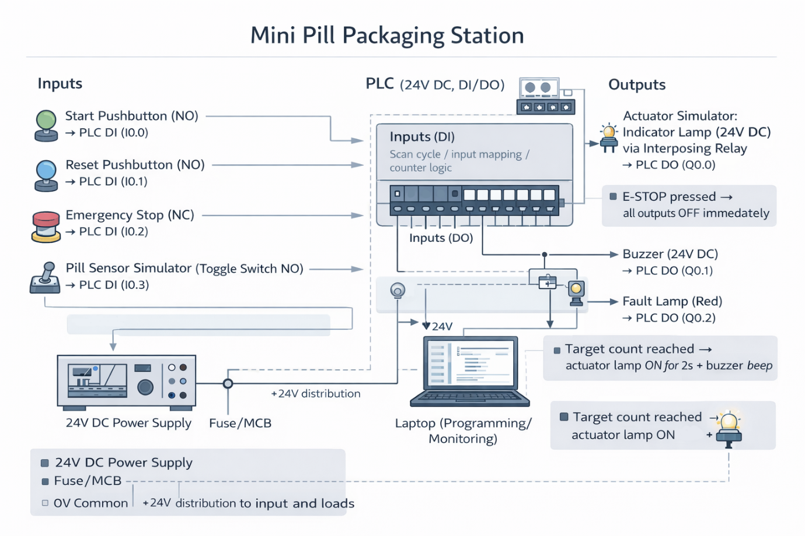
Figure 0.2 Demo Diagram

This diagram is a smaller “bench rig” version of the same station, designed to be easy to build and demonstrate. It keeps the same key inputs (Start, Reset, E-STOP (NC), pill sensor simulator) and outputs (actuator output and buzzer output), but uses safe substitutes like a lamp to represent the actuator and a switch to simulate the pill sensor pulses.
The IO tags (for example I0.0–I0.3 and Q0.0–Q0.1) match the wiring and the PLC program, so it’s clear what each device connects to. With this rig, it’s possible to demonstrate:
- normal operation (start cycle, simulate pill counts, actuator output turns on, buzzer indicates completion)
- safe shutdown with E-STOP
- basic faults (like the pill sensor switch being “stuck” ON or not changing)
The power section (24 V DC supply, 0 V common, and relay/driver if used) shows how the devices are powered and why outputs may use an interposing relay for safety and load handling.

SECTION 1 — DEMONSTRATION OVERVIEW (WHAT YOU BUILT AND WHAT YOU WILL SHOW)
1.1 Short purpose statement (3–6 lines)
Write what your rig demonstrates:
- PLC handling of inputs and outputs for a pill packaging station (Start/Reset/E-Stop/Pill sensor; Actuator/Buzzer)
- Signal conditioning (debounce/filter) and mapping
- Operation cycle and error/fault behaviour
- Troubleshooting and noise discussion
- Communication links/standards and (where possible) HMI/SCADA integration concept or example
Suggested sentence starters:
- “This demonstration shows the PLC processing digital inputs, executing logic in the scan cycle, and actuating outputs for a simplified pill packaging station.”
- “The rig includes safe simulation of a pill sensor, an actuator output, and buzzer indications, plus recorded evidence of normal operation and fault conditions.”

1.2 Evidence map (fill in)
- Wiring diagram evidence: [timestamp / appendix / screenshot reference]
- IO allocation table evidence: [timestamp / appendix / screenshot reference]
- Normal cycle run evidence: [timestamp range]
- Error simulations evidence: [timestamp range]
- Troubleshooting evidence: [timestamp range]
- Communications discussion evidence (P3/P4): [page/section]
- HMI/SCADA integration evidence (M2/M3): [page/section + screenshot if any]
- Convergence rationale (D2): [page/section]

SECTION 2 — REQUIRED DIAGRAMS (INSERT THESE TWO IMAGES IN YOUR TEMPLATE DOCUMENT)
2.1 Main station diagram (context diagram)
[Insert Image 1: “Pill Counting and Packaging Station – System Diagram”]
Caption: Figure 1 – <<Write what the diagram shows and why it is relevant>>
2.2 Simple demonstration sub-system diagram (bench rig)
[Insert Image 2: “Mini PLC Demonstration Rig – Inputs/Outputs/Power”]
Caption: Figure 2 – <<Write what the sub diagram shows and how it maps to the real station>>
(Write 4–8 lines explaining how Image 2 is a simplified but valid representation of Image 1.)

SECTION 3 — SYSTEM DOCUMENTATION (IO ALLOCATION TABLE + SIGNAL MAPPING)
3.1 IO allocation table (required)
Provide a table in your document (you can paste it from your IDE notes) including:
- Tag / Name
- Address (e.g., I0.0, Q0.0)
- Type (DI/DO)
- Device (Start PB, Reset PB, E-stop, Pill sensor sim, Actuator relay/lamp, buzzer)
- Electrical level (24V DC, etc.)
- Notes (NO/NC, pull-up/down, debouncing/filtering, safety notes)
[Insert IO allocation table]
Caption: Table 1 – IO allocation for Task 2 demonstration rig
3.2 Input mapping explanation (short but specific)
For each input, write:
- Physical device
- Expected behaviour
- How it is interpreted in the program (e.g., rising edge detect, normally closed logic inversion)
- Any filtering/debounce applied
Example prompts (complete each line):
- Start (I0.0): “Pressed = 1”, used to transition from IDLE to COUNTING. Debounce: <<yes/no and method>>.
- Reset (I0.1): clears faults and returns to IDLE if safe conditions met.
- E-stop (I0.2, NC): “Healthy = 1”, “Pressed/broken wire = 0”, forces outputs OFF.
- Pill sensor sim (I0.3): each toggle/pulse increments counter using <<edge detect method>>.

SECTION 4 — WIRING AND CONFIGURATION (REQUIRED)
4.1 Wiring proof (required)
Provide:
- A wiring diagram OR neat wiring photo annotated with labels matching IO table
- Clear showing of Start, Reset, E-stop, Pill sensor sim
- Clear showing of relay outputs (actuator output and buzzer output)
[Insert wiring diagram / annotated wiring photo]
Caption: Figure 3 – Wiring connections for inputs and outputs

4.2 Configuration notes (fill in)
- Input voltage type: <<24VDC DI / other>>
- Output type: <<relay output / transistor output / interposing relay used>>
- Output protection used (if any): <<flyback diode / snubber / fuse>>
- Common 0V wiring approach: <<describe briefly>>
- Any grounding/shielding used: <<describe briefly>>
4.3 Debouncing and filtering (required “if relevant”)
State clearly:
- Which signals need debouncing (typically pushbuttons) and why
- Which signals might need filtering (noisy sensor line, relay bounce)
- What method you used:
  - Software debounce (timer-based)
  - One-shot/rising edge (anti-repeat)
  - Input filter parameters (if PLC supports)
Write in a “what you did + why” format:
- “Start input is debounced by <<method>> to prevent multiple scans registering multiple presses.”
- “Pill sensor uses rising-edge detection to count each event once even if the input remains high for several scans.”
[Insert screenshot of program logic showing debounce/edge detect blocks]
Caption: Figure 4 – Debounce/edge-detection implementation

SECTION 5 — OPERATION CYCLE DEMONSTRATION (NORMAL RUN) (REQUIRED)
5.1 Demonstration script (use these steps in your video)
Record a continuous sequence showing:
- Power on / initial state shown in IDE monitoring (inputs and outputs OFF as expected)
- Verify E-stop healthy state (show I0.2 reading)
- Press Start (show I0.0 toggling)
- Simulate pill sensor events (toggle/pulse I0.3) and show counter incrementing
- At target count reached, show actuator output energising (Q0.0)
- Show buzzer output behaviour (Q0.1) for completion
- Show system returns to safe state / ready state (as per your design)
Include timestamps:
- Normal cycle start timestamp: <mm:ss>
- Pill count event timestamp example: <mm:ss>
- Actuator output ON timestamp: <mm:ss>
- Completion indication timestamp: <mm:ss>
5.2 Evidence screenshots
[Insert screenshot of live monitoring showing IO states during the cycle]
Caption: Figure 5 – PLC IO monitoring during normal operation
[Insert screenshot showing counter/timer values changing]
Caption: Figure 6 – Counter/timer evidence during pill counting

SECTION 6 — ERROR SIMULATION (REQUIRED)
You must demonstrate at least two faults and show safe response.
6.1 Fault 1: Sensor stuck / sensor fault (example)
Describe the fault:
- What “stuck” means in your rig (e.g., pill sensor stays ON, or never changes)
- How the PLC detects it (timeout, no pulses in time, unexpected continuous state)
- Expected response (halt cycle, outputs OFF, buzzer fault pattern, fault flag set)
Video evidence:
- Fault 1 demonstration timestamp: <mm:ss> to <mm:ss>
[Insert screenshot showing fault flag / state + outputs de-energised]
Caption: Figure 7 – Fault 1 state and outputs OFF
6.2 Fault 2: Emergency stop pressed (required)
Describe behaviour:
- E-stop input changes to unsafe state
- Outputs drop immediately
- Reset required to recover (explain your reset conditions)
Video evidence:
- E-stop press timestamp: <mm:ss>
- Output drop visible timestamp: <mm:ss>
[Insert screenshot showing E-stop state and outputs OFF]
Caption: Figure 8 – E-stop event and safe shutdown
(Optional additional faults if you want stronger evidence)
- Start button bounce / false triggers
- Relay output fault (simulated by unplugging load)
- Wrong wiring (swap input lines and diagnose)

SECTION 7 — TROUBLESHOOTING (REQUIRED)
7.1 Fault diagnosis procedure (write as steps you actually did)
Demonstrate at least one troubleshooting workflow. Example structure:
- Observe symptom (e.g., actuator output not energising)
- Check program state / permissives (E-stop OK? fault bit set?)
- Check input status (I0.x) in live monitor
- Force/override output in software (if allowed) OR test output with meter
- Verify wiring continuity and correct terminal mapping
- Conclude root cause and fix (wiring correction/program fix)
Include evidence:
- What tool you used: <<multimeter / IDE watch window / forcing IO>>
- What you observed: <<specific readings / bits>>
Video evidence:
- Troubleshooting timestamp: <mm:ss> to <mm:ss>
[Insert photo/screenshot of troubleshooting (meter reading, IDE watch window, wiring correction)]
Caption: Figure 9 – Troubleshooting evidence and resolution

7.2 Signal integrity and noise discussion (required)
Write a short section covering:
- Where noise comes from (relays, inductive loads, long cables, nearby motors)
- What symptoms it causes (false triggers, bouncing, intermittent faults)
- Mitigation strategies:
  - Shielded cables / twisted pairs for sensor wiring
  - Proper grounding and separation of power/signal wiring
  - Input filtering / debounce / edge detect
  - Flyback diode or snubber on inductive loads
  - Use of opto-isolation / interposing relays where needed
Keep it practical: “In this station, the most likely noise sources are <<…>>; therefore the recommended mitigations are <<…>>.”

SECTION 8 — COMMUNICATION LINKS AND STANDARDS (LO2.P3)
Goal: illustrate differences between communication links and standards used within PLC systems.
8.1 Communication links vs standards (write clearly)
Define and compare (use short paragraphs + examples):
- Communication link (physical/data link layer examples):
  - Ethernet, RS-232, RS-485, USB
- Communication standard/protocol examples (application/industrial protocols):
  - Modbus RTU, Modbus TCP, PROFINET, EtherNet/IP, CANopen (choose relevant ones)
Write at least ONE comparison paragraph that contrasts:
- Speed/bandwidth
- Distance
- Noise immunity
- Topology (point-to-point, bus, star)
- Typical use in PLC systems
[Insert a small diagram showing PLC connected via Ethernet and/or RS-485]
Caption: Figure 10 – Example PLC communication links and protocols
8.2 Evidence statement (tie to your demo)
Even if your demo is local, state what is used:
- “The PLC was programmed via <<USB/Ethernet>> (link), while industrial networking may use <<protocol>> for field devices.”

SECTION 9 — NETWORKED BUS PLC SYSTEMS (LO2.P4)
Goal: review advantages of using networked bus PLC systems.
Write a “review” using headings:
Advantages (include at least 6, explained):
- Reduced wiring vs point-to-point IO
- Easier expansion (add nodes)
- Centralised diagnostics and device status
- Faster commissioning with standard device profiles
- Data availability for HMI/SCADA and logging
- Maintenance benefits (fault location, predictive maintenance potential)
Limitations/considerations (include at least 4):
- Configuration complexity
- Network security requirements
- Single point of failure risks (switch/cable)
- Deterministic timing requirements and network loading
[Insert a simple bus topology diagram (PLC + remote IO + HMI/SCADA)]
Caption: Figure 11 – Example networked bus PLC architecture

SECTION 10 — HMI AND SCADA INTEGRATION (LO2.M2 and LO2.M3)
10.1 Show how PLCs in industry integrate with HMIs and SCADA (LO2.M2)
You must “show” integration. This can be done by one of these options (choose one and provide evidence):
Option A (preferred if available): Actual integration evidence
- Connect PLC (or OpenPLC) to an HMI/SCADA tool (e.g., Node-RED dashboard, Ignition demo, WinCC, CODESYS HMI, etc.)
- Show live tags: start, reset, e-stop status, pill count, actuator state, fault state
Evidence required:
[Insert screenshot of HMI/SCADA screen with live tags]
Caption: Figure 12 – HMI/SCADA monitoring of PLC tags
Option B (acceptable if you cannot build it): “Industry integration demonstration” using diagrams + tag list
- Provide a clear architecture diagram + tag mapping table showing how the PLC would expose data to HMI/SCADA (protocol + tags)
Evidence required:
[Insert integration architecture diagram + tag list]
Caption: Figure 12 – Proposed PLC-to-HMI/SCADA integration and tags
10.2 Evaluate the use of SCADA and HMIs in industry (LO2.M3)
Write an evaluation with pros/cons and a conclusion for THIS application (pill packaging station). Include:
Benefits:
- Operator visibility and alarms
- Trend logging (pill count rate, downtime)
- Faster troubleshooting
- Traceability (regulated environment)
Drawbacks/risks:
- Added complexity and cost
- Training needs
- Security and access control
- Network dependence
Conclude with: “For this station, HMI/SCADA is <<recommended/not recommended>> at <<scale>> because <<reasons>>.”

SECTION 11 — CONVERGENCE RATIONALE (LO2.D2)
LO2.D2 requires a justified and valid rationale for the convergence of PLCs/HMIs and SCADA control systems.
Write a structured argument (minimum 3 paragraphs) answering:
- What “convergence” means (integrated PLC + HMI + SCADA functionality, shared networks, shared data models)
- Why industry is moving this way (data availability, Industry 4.0, remote maintenance, centralized monitoring, reduced engineering time)
- What must be controlled (cybersecurity, segmentation, role-based access, validation)
Your rationale MUST include:
- A clear position: “Convergence is beneficial for <<reasons>> in this scenario, provided <<controls>> are implemented.”
- At least one risk and mitigation:
  - Risk: cyber intrusion / downtime due to network issue
  - Mitigation: network segmentation, VLANs, firewall rules, backups, user access control
[Insert a convergence architecture diagram (PLC/HMI/SCADA on common network + security boundary)]
Caption: Figure 13 – PLC/HMI/SCADA convergence example with security boundary

SECTION 12 — LAB RECORD (REQUIRED)
Provide a dated lab record entry (can be typed, but must look like a log). Include:
Date: <<date>>
Session start/end time: <<time>>
Objective: <<what you aimed to demonstrate>>
Equipment used:
- PLC: <<…>>
- Power supply: <<…>>
- Relays/lamps/buzzer: <<…>>
- Software: <<…>>
- Measurement tools: <<…>>
Build notes (brief):
- Wiring completed: <<yes/no>>
- Issues encountered: <<list>>
- Fixes applied: <<list>>
- Test cases executed: normal cycle + fault cases
Results summary:
- Normal cycle result: <<pass/fail + notes>>
- Fault 1 result: <<pass/fail + notes>>
- Fault 2 result: <<pass/fail + notes>>
Sign-off:
Student signature: <<…>>
Assessor initials (if used): <<…>>

FINAL SUBMISSION CHECKLIST (MATCHES BRIEF)
- Wiring diagrams with input/output connections: YES/NO
- IO allocation table: YES/NO
- Live demonstration of operation cycle (recorded): YES/NO
- Error simulation results: YES/NO
- Troubleshooting procedures and findings: YES/NO
- Lab record documentation: YES/NO
- Discussion of signal integrity and mitigation strategies: YES/NO

Bibliography
There are no sources in the current document.

